**Description**

**Overview:**

**Develop a system that automatically manages the lifecycle of a web application hosted on EC2 instances, monitors its health, and reacts to changes in traffic by scaling resources.  Furthermore, administrators receive notifications regarding the infrastructure's health and scaling events.**

**Detailed Breakdown:**

**1. Web Application Deployment:**

 - Use `boto3` to:

 - Create an S3 bucket to store your web application's static files.

 - Launch an EC2 instance and configure it as a web server (e.g., Apache, Nginx).  - Deploy the web application onto the EC2 instance.

**2. Load Balancing with ELB:**

 - Deploy an Application Load Balancer (ALB) using `boto3`.

 - Register the EC2 instance(s) with the ALB.

**3. Auto Scaling Group (ASG) Configuration:**

- Using `boto3`, create an ASG with the deployed EC2 instance as a template.

 - Configure scaling policies to scale in/out based on metrics like CPU utilization or network traffic.

**4. SNS Notifications:**

 - Set up different SNS topics for different alerts (e.g., health issues, scaling events, high traffic).

 - Integrate SNS with Lambda so that administrators receive SMS or email notifications.

**5. Infrastructure Automation:**

 - Create a single script using `boto3` that:

 - Deploys the entire infrastructure.

 - Updates any component as required.

 - Tears down everything when the application is no longer needed.

**6. Optional Enhancement – Dynamic Content Handling:**

- Store user-generated content or uploads on S3.

 - When a user uploads content to the web application, it gets temporarily stored on the  EC2 instance. A background process (or another Lambda function) can move this to the S3  bucket and update the application's database to point to the content's new location on S3.

**Objectives:**

- Gain a comprehensive understanding of key AWS services and their integration. - Understand the lifecycle of a dynamic web application and its infrastructure.

- Learn how to automate infrastructure deployment and management tasks using boto3. - Experience with real-time monitoring and alerting systems

**Github Url:** [**https://github.com/Ram495-ctrl/Monitoring-Scaling-and-Automation.git**](https://github.com/Ram495-ctrl/Monitoring-Scaling-and-Automation.git)

**Create boto3 code:**

from optparse import Values

import boto3

import time

import json

import yaml

AWS_REGION = 'us-west-2'

# Create a session using 'default' profile

session = boto3.Session(profile_name="default", region_name=AWS_REGION)

# Initialize all clients

s3 = session.client('s3')

ec2 = session.client('ec2')

elb = session.client('elbv2')

autoscaling = session.client('autoscaling')

sns = session.client('sns')

# Step 1: Providing all values by using yaml file

def read_values_from_file(file_path):

    with open(file_path, 'r') as file:

        values = yaml.safe_load(file)

    return values

# Step 2: Create S3 Bucket before checking if it exists

def create_s3_bucket(bucket_name):

    try:

        # Check if the bucket exists

        response = s3.head_bucket(Bucket=bucket_name)

        print(f"S3 bucket already exists: {bucket_name}")

        return bucket_name

    except s3.exceptions.ClientError as e:

        error_code = e.response['Error']['Code']

        if error_code == '403':

            print(f"Access denied to check bucket {bucket_name}. Ensure you have correct permissions.")

            return None

        elif error_code == '404':

            # Bucket doesn't exist, proceed to create it

            try:

                response = s3.create_bucket(

                    Bucket=bucket_name,

                    CreateBucketConfiguration={

                        'LocationConstraint': session.region_name

                    }

                )

                print(f"S3 bucket created: {bucket_name}")

                return bucket_name

            except s3.exceptions.BucketAlreadyExists:

                print(f"Bucket name '{bucket_name}' already exists globally. Please choose a different name.")

                return None

            except Exception as e:

                print(f"Error creating bucket: {e}")

                return None

        else:

            print(f"Error checking bucket: {e}")

            return None

# Step 3: Create Security Group or use existing

def create_security_group(description, security_group_name):

    try:

        # Check if the security group already exists

        response = ec2.describe_security_groups(

            Filters=[{'Name': 'group-name', 'Values': [security_group_name]}]

        )

        if response['SecurityGroups']:

            security_group_id = response['SecurityGroups'][0]['GroupId']

            print(f"Security group already exists: {security_group_id}")

            return security_group_id

        else:

            # If the security group doesn't exist, create a new one

            response = ec2.create_security_group(

                GroupName=security_group_name,

                Description=description

            )

            security_group_id = response['GroupId']

            print(f"Security group created: {security_group_id}")

            ec2.create_tags(

                Resources=[security_group_id],

                Tags=[{'Key': 'Name', 'Value': security_group_name}]

            )

            print(f"Tags added to security group: {security_group_name}")

            # Set inbound rules

            ec2.authorize_security_group_ingress(

                GroupId=security_group_id,

                IpPermissions=[

                    {

                        'IpProtocol': 'tcp',

                        'FromPort': 80,

                        'ToPort': 80,

                        'IpRanges': [{'CidrIp': '0.0.0.0/0'}]

                    },

                    {

                        'IpProtocol': 'tcp',

                        'FromPort': 22,

                        'ToPort': 22,

                        'IpRanges': [{'CidrIp': '0.0.0.0/0'}]

                    }

                ]

            )

            print("Inbound traffic rules applied to security group")

            return security_group_id

    except Exception as e:

        print(f"Error creating or checking security group: {e}")

# Step 4: Launch an EC2 instance or use existing

def launch_ec2_instance(security_group_id, ami_id, instance_type, ec2_name):

    try:

        # Check if an instance with the tag 'WebServer' already exists

        response = ec2.describe_instances(

            Filters=[

                {'Name': 'tag:Name', 'Values': [ec2_name]},

                {'Name': 'instance-state-name', 'Values': ['running', 'pending']}

            ]

        )

        if response['Reservations']:

            instance_id = response['Reservations'][0]['Instances'][0]['InstanceId']

            print(f"EC2 instance already exists: {instance_id}")

            return instance_id

        else:

            # Launch new instance if not found

            response = ec2.run_instances(

                ImageId=ami_id,

                InstanceType=instance_type,

                MinCount=1,

                MaxCount=1,

                UserData='''

                    #!/bin/bash

                    sudo apt update

                    sudo apt install -y nginx

                    sudo systemctl start nginx

                    sudo systemctl enable nginx

                    echo "<html><body><h1>Welcome to My Web App</h1></body></html>" > /var/www/html/index.html

                ''',

                TagSpecifications=[{

                    'ResourceType': 'instance',

                    'Tags': [{'Key': 'Name', 'Value': ec2_name}]

                }],

                SecurityGroupIds=[security_group_id]

            )

            instance_id = response['Instances'][0]['InstanceId']

            print(f"EC2 Instance launched: {instance_id}")

            return instance_id

    except Exception as e:

        print(f"Error launching EC2 instance: {e}")

# Step 5: Create Load Balancer and Target Group or use existing

def create_load_balancer(instance_id, security_group_id, subnet_id, vpc_id, loadbalancer_name, lb_targetgroup):

    try:

        # Check if the ALB exists

        response = elb.describe_load_balancers(

            Names=[loadbalancer_name]

        )

        load_balancer_arn = response['LoadBalancers'][0]['LoadBalancerArn']

        print(f"Load Balancer already exists: {load_balancer_arn}")

        # Check if the target group exists

        tg_response = elb.describe_target_groups(

            Names=[lb_targetgroup]

        )

        target_group_arn = tg_response['TargetGroups'][0]['TargetGroupArn']

        print(f"Target Group already exists: {target_group_arn}")

    except elb.exceptions.LoadBalancerNotFoundException:

        # If load balancer doesn't exist, create a new one

        response = elb.create_load_balancer(

            Name=loadbalancer_name,

            Subnets=subnet_id,

            SecurityGroups=[security_group_id],

            Scheme='internet-facing',

            Type='application',

            Tags=[{'Key': 'Name', 'Value': loadbalancer_name}]

        )

        load_balancer_arn = response['LoadBalancers'][0]['LoadBalancerArn']

        print(f"Load Balancer created: {load_balancer_arn}")

        # Create target group

        tg_response = elb.create_target_group(

            Name=lb_targetgroup,

            Protocol='HTTP',

            Port=80,

            VpcId=vpc_id,

            TargetType='instance',

            HealthCheckProtocol='HTTP',

            HealthCheckPort='80',

            HealthCheckPath='/',

            Matcher={'HttpCode': '200'}

        )

        target_group_arn = tg_response['TargetGroups'][0]['TargetGroupArn']

        print(f"Target Group created: {target_group_arn}")

    return load_balancer_arn, target_group_arn

# Step 6: Register EC2 Instances with Target Group

def register_instances_with_target_group(target_group_arn, instance_id):

    try:

        response = elb.register_targets(

            TargetGroupArn=target_group_arn,

            Targets=[

                {

                    'Id': instance_id,

                    'Port': 80

                }

            ]

        )

        print(f"EC2 instance {instance_id} registered with target group {target_group_arn}")

    except Exception as e:

        print(f"Error registering instance with target group: {e}")

# Step 7: Create Listener for ALB

def create_listener(load_balancer_arn, target_group_arn):

    try:

        response = elb.create_listener(

            LoadBalancerArn=load_balancer_arn,

            Protocol='HTTP',

            Port=80,

            DefaultActions=[{

                'Type': 'forward',

                'TargetGroupArn': target_group_arn

            }]

        )

        listener_arn = response['Listeners'][0]['ListenerArn']

        print(f"Listener created: {listener_arn}")

        #  # Create HTTPS listener (port 443)

        # https_response = elb.create_listener(

        #     LoadBalancerArn=load_balancer_arn,

        #     Protocol='HTTPS',

        #     Port=443,

        #     Certificates=[{

        #         'CertificateArn': certificate_arn  # provided certificate ARN

        #     }],

        #     DefaultActions=[{

        #         'Type': 'forward',

        #         'TargetGroupArn': target_group_arn

        #     }]

        # )

        # https_listener_arn = https_response['Listeners'][0]['ListenerArn']

        # print(f"HTTPS Listener created: {https_listener_arn}")

    except Exception as e:

        print(f"Error creating listener: {e}")

# Step 8: Create Launch-templete or use existing

def create_launch_template(instance_id, launch_template_name):

    try:

        # Check if Launch Template already exists

        response = ec2.describe_launch_templates(

            LaunchTemplateNames=[launch_template_name]

        )

        if response['LaunchTemplates']:

            print(f"Launch Template {launch_template_name} already exists.")

            return response['LaunchTemplates'][0]['LaunchTemplateId']

    except ec2.exceptions.ClientError as e:

        error_code = e.response['Error']['Code']

        if error_code == 'InvalidLaunchTemplateName.NotFoundException':

            print(f"Launch Template {launch_template_name} not found. Proceeding to create it.")

        else:

            print(f"Error checking for launch template: {e}")

            return None

    try:

        # Fetch instance details

        response = ec2.describe_instances(InstanceIds=[instance_id])

        instance = response['Reservations'][0]['Instances'][0]

        # Create the Launch Template

        launch_template_data = {

            'ImageId': instance['ImageId'],

            'InstanceType': instance['InstanceType'],

            'SecurityGroupIds': [sg['GroupId'] for sg in instance['SecurityGroups']],

            'TagSpecifications': [{

                'ResourceType': 'instance',

                'Tags': instance['Tags']

            }]

        }

        # Only add KeyName if it's not None

        if instance.get('KeyName'):

            launch_template_data['KeyName'] = instance['KeyName']

        response = ec2.create_launch_template(

            LaunchTemplateName=launch_template_name,

            LaunchTemplateData=launch_template_data

        )

        launch_template_id = response['LaunchTemplate']['LaunchTemplateId']

        print(f"Launch Template created: {launch_template_id}")

        return launch_template_id

    except Exception as e:

        print(f"Error creating launch template: {e}")

        return None

# Step 9: Creating Auto Scaling Group

      # Check if Auto Scaling Group exists and create if it doesn't

def auto_scaling_group(launch_template_id, target_group_arn, subnet_id, auto_scaling_group_name, desired_capacity, min_size, max_size ):

    try:

        # Check if the Auto Scaling Group already exists

        response = autoscaling.describe_auto_scaling_groups(

            AutoScalingGroupNames=[auto_scaling_group_name]

        )

        if response['AutoScalingGroups']:

            print(f"Auto Scaling Group {auto_scaling_group_name} already exists.")

            return  # ASG exists, no need to create

    except Exception as e:

        print(f"Auto Scaling Group not found or error occurred: {e}")

    # Create an Auto Scaling Group if it doesn't exist

    try:

        autoscaling.create_auto_scaling_group(

            AutoScalingGroupName=auto_scaling_group_name,

            LaunchTemplate={

                'LaunchTemplateId': launch_template_id,

                'Version': '$Latest'

            },

            MinSize=min_size,

            MaxSize=max_size,

            DesiredCapacity=desired_capacity,

            VPCZoneIdentifier=','.join(subnet_id),

            TargetGroupARNs=[target_group_arn],

            HealthCheckType='EC2',

            HealthCheckGracePeriod=300,

            Tags=[{

                'Key': 'Name',

                'Value': auto_scaling_group_name,

                'PropagateAtLaunch': True

            }]

        )

        print("Auto Scaling Group created successfully.")

    except Exception as e:

        print(f"Error creating Auto Scaling Group: {e}")

# Step 10: Creating scaling policies to scale in/out

def manage_scaling_policy(auto_scaling_group_name):

    try:

        # Check if the target tracking policy already exists

        response = autoscaling.describe_policies(

            AutoScalingGroupName=auto_scaling_group_name,

            PolicyTypes=['TargetTrackingScaling']

        )

        existing_policies = {policy['PolicyName'] for policy in response['ScalingPolicies']}

        # Create or update a single target tracking policy if it doesn't exist

        if 'cpu-target-tracking-policy' not in existing_policies:

            target_tracking_policy = autoscaling.put_scaling_policy(

                AutoScalingGroupName=auto_scaling_group_name,

                PolicyName='cpu-target-tracking-policy',

                PolicyType='TargetTrackingScaling',

                TargetTrackingConfiguration={

                    'PredefinedMetricSpecification': {

                        'PredefinedMetricType': 'ASGAverageCPUUtilization'

                    },

                    'TargetValue': 70.0,

                    'DisableScaleIn': False,

                }

            )

            print(f"Target Tracking Policy ARN: {target_tracking_policy['PolicyARN']}")

        else:

            print("Target tracking policy already exists.")

    except Exception as e:

        print(f"Error managing scaling policy: {e}")

# Step 11: Create SNS Topic for Alerts

def create_sns_topic(sns_topic_name):

    try:

        response = sns.create_topic(Name=sns_topic_name)

        topic_arn = response['TopicArn']

        print(f"SNS topic created: {topic_arn}")

        return topic_arn

    except Exception as e:

        print(f"Error creating SNS topic: {e}")

        return None

# Step 12: Subscribe to SNS Topic

def subscribe_to_topic(topic_arn, protocol, endpoint):

    try:

        response = sns.subscribe(

            TopicArn=topic_arn,

            Protocol=protocol,

            Endpoint=endpoint

        )

        subscription_arn = response['SubscriptionArn']

        print(f"Subscription created: {subscription_arn}")

    except Exception as e:

        print(f"Error subscribing to SNS topic: {e}")

# Step 13: Publish Message to SNS Topic

def publish_sns_message(topic_arn, subject, message):

    try:

        response = sns.publish(

            TopicArn=topic_arn,

            Subject=subject,

            Message=message

        )

        print(f"Message published to topic {topic_arn}: {response['MessageId']}")

    except Exception as e:

        print(f"Error publishing message to SNS topic: {e}")

# Full Deployment Script

def deploy_web_application():

    file_path = 'values.yaml'

    values = read_values_from_file(file_path)

    # Step 1: Create S3 Bucket

    bucket_name = create_s3_bucket(values['bucket_name'])

    # Step 2: Create Security Group

    security_group_id = create_security_group('Security group for Web App', values['security_group_name'])

    # Step 3: Launch EC2 Instance

    instance_id = launch_ec2_instance(security_group_id, values['image_id'], values['instance_type'], values['ec2_name'])

    waiter = ec2.get_waiter('instance_running')

    waiter.wait(InstanceIds=[instance_id])

    # Step 4: Create Load Balancer and Target group

    load_balancer_arn, target_group_arn = create_load_balancer(instance_id, security_group_id, values['subnet_id'], values['vpc_id'], values['loadbalancer_name'], values['lb_targetgroup'])

    # Step 5: Register EC2 Instances with Target Group

    register_instances_with_target_group(target_group_arn, instance_id)

    # Step 6: Create Listener for Load Balancer

    create_listener(load_balancer_arn, target_group_arn)

    # Step 7: Check/Create Launch Template

    launch_template_id = create_launch_template(instance_id, values['launch_template_name'])

    # Step 8: Create Auto Scaling Group

    auto_scaling_group_name = auto_scaling_group(launch_template_id, target_group_arn, values['subnet_id'], values['auto_scaling_group_name'], values['desired_capacity'], values['min_size'], values['max_size'])

    # Step 9: Creating Scaling policy for ASG

    manage_scaling_policy(values['auto_scaling_group_name'])

    # Step 10: Creating SNS topics for alerts

    health_alert_topic = create_sns_topic(values['sns_topic_name'])

    subscribe_to_topic(health_alert_topic, values['protocol'], values['email_id'])

    publish_sns_message(health_alert_topic, values['subject'], values['message'])

    # Store resource IDs in a JSON file

    resources = {

        'bucket_name': bucket_name,

        'security_group_id': security_group_id,

        'instance_id': instance_id,

        'load_balancer_arn': load_balancer_arn,

        'target_group_arn': target_group_arn,

        'launch_template_id': launch_template_id,

        'auto_scaling_group_name': values['auto_scaling_group_name'],

        'sns_topic': health_alert_topic

    }

    with open('resources.json', 'w') as f:

        json.dump(resources, f, indent=4)

# Run the deployment

deploy_web_application()

enter required in values.yaml

## ASG Values

auto_scaling_group_name: Ram_ASG

launch_configuration_name: my-lc1

launch_template_name: mylc

min_size: 1

max_size: 2

desired_capacity: 1

image_id: ami-05134c8ef96964280

instance_type: t2.micro

subnet_id: ['subnet-0f30c30418def6379', 'subnet-03ca36de9a927fe8e']

security_group_name: Ram_WebAppSecurityGroup1

bucket_name: ram1234345678

vpc_id: vpc-0321f38a7b594180d

loadbalancer_name: Ramwebapp-lb1

lb_targetgroup: Ramwebapp-tg1

ec2_name: Ram_webserver1

sns_topic_name: Ram-sns

protocol: email

email_id: [ramasrinivas495@gmail.com](mailto:ramasrinivas495@gmail.com)

subject: 'Test Alert'

message: 'This is a test alert for health issues'

**Execute the app.py file**

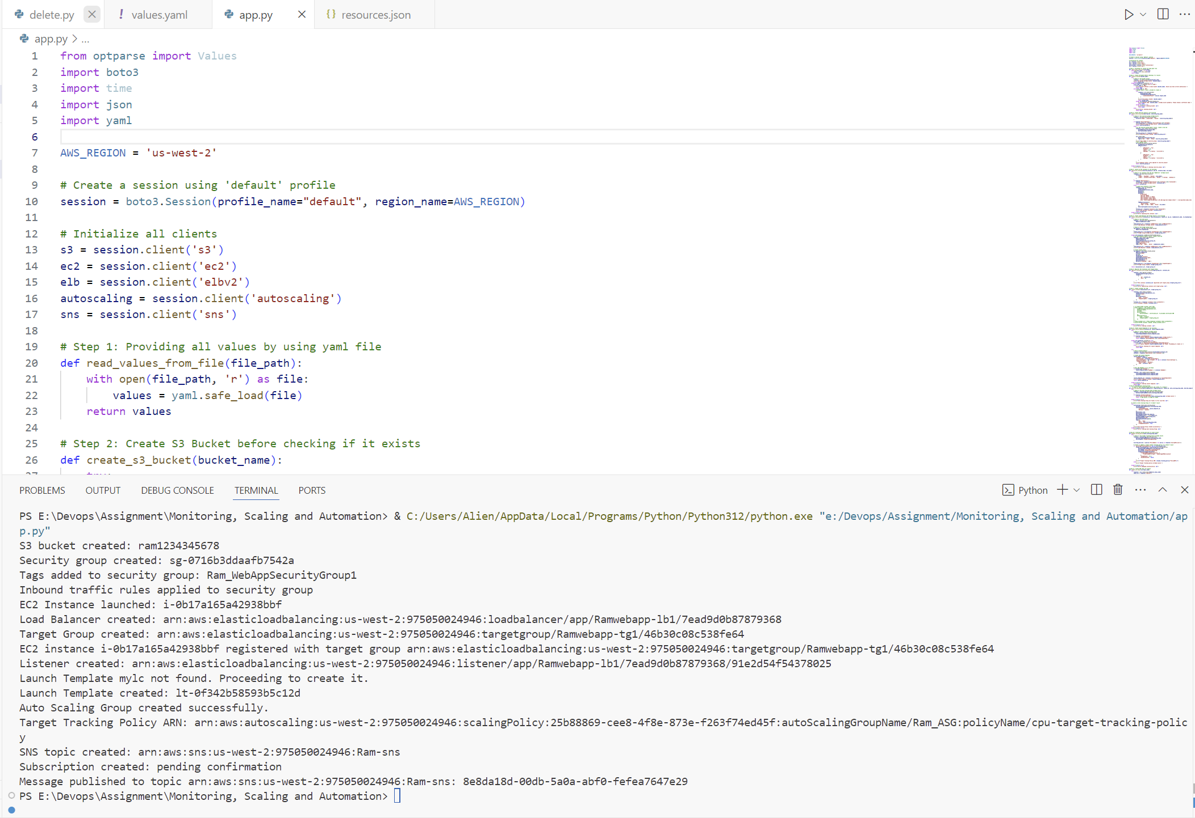

EC2 created- Ram_webserver1

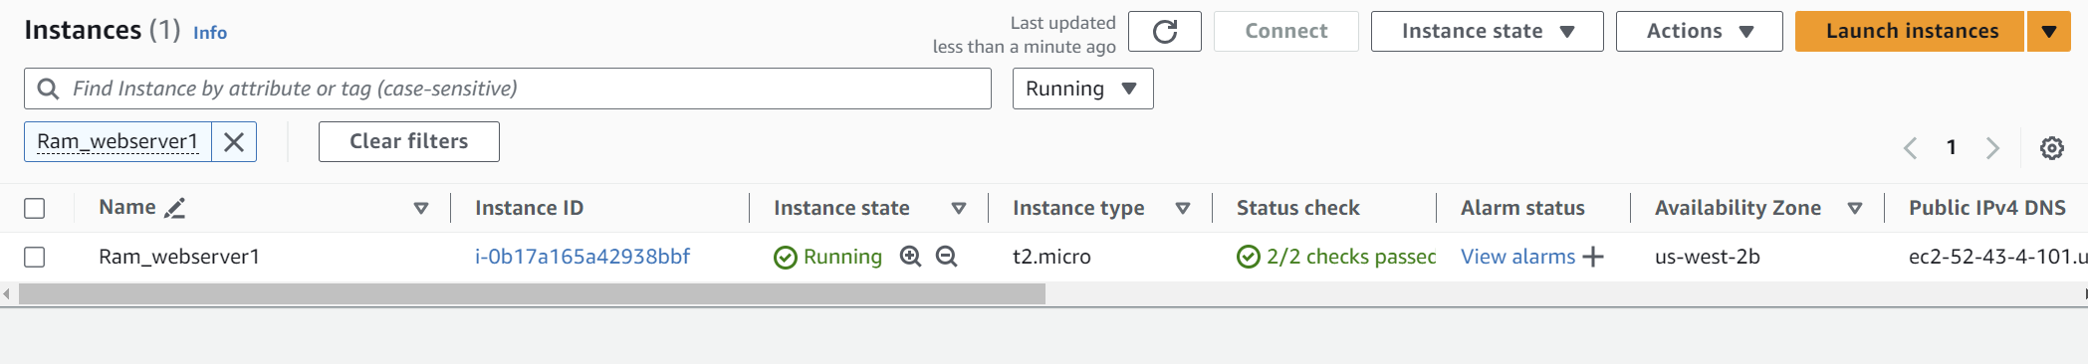

2. Load balancer-Ramwebapp-lb1

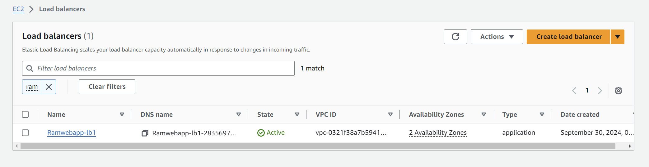

3. ASG created – Ram_ASG

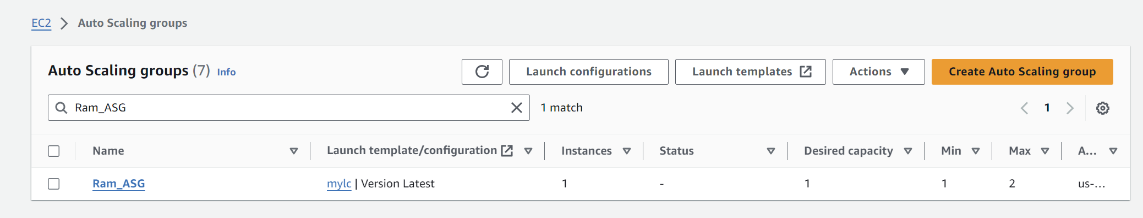

Index file create in /var/www/html/

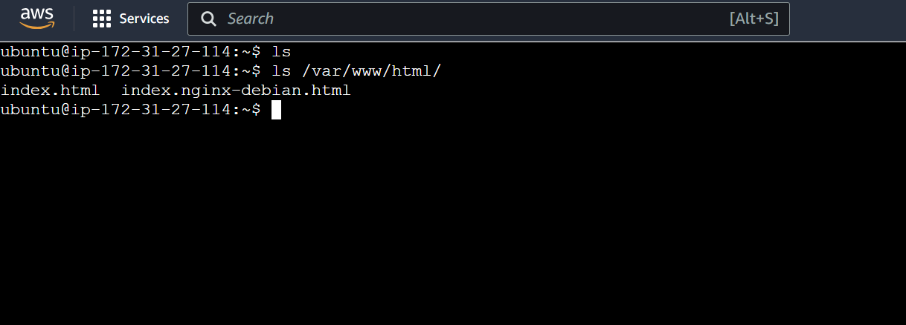

4. SNS Notifications:

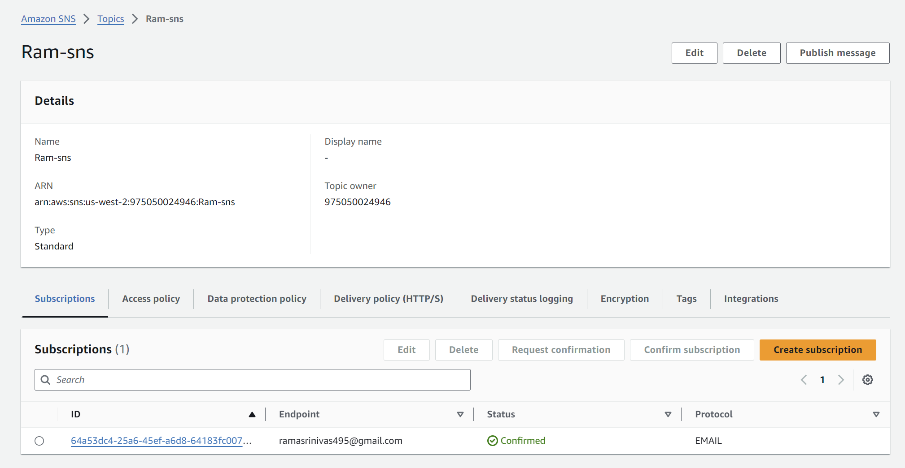

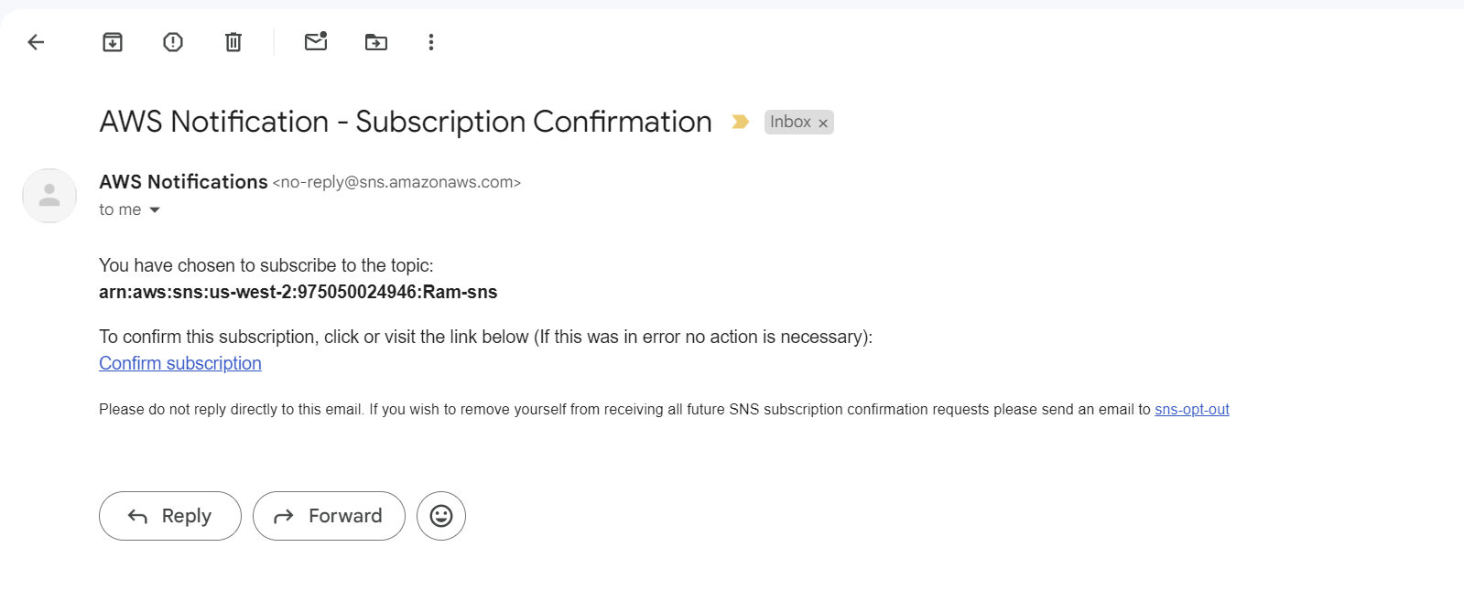

5. Infrastructure Automation:

Create python for deletion and execute

import boto3

import json

import time

AWS_REGION = 'us-west-2'

# Create a session using 'herovired' profile

session = boto3.Session(profile_name="default", region_name=AWS_REGION)

# Initialize all clients

s3 = session.client('s3')

ec2 = session.client('ec2')

elb = session.client('elbv2')

autoscaling = session.client('autoscaling')

sns = session.client('sns')

def delete_resources():

    try:

        with open('resources.json', 'r') as f:

            resources = json.load(f)

        # Deleting S3 bucket

        try:

            print(f"Deleting S3 bucket: {resources['bucket_name']}...")

            s3.delete_bucket(Bucket=resources['bucket_name'])

            print("S3 bucket deleted successfully.")

        except s3.exceptions.ClientError as e:

            print(f"Error deleting S3 bucket: {e}")

        # Deleting Auto Scaling Group

        try:

            print(f"Deleting Auto Scaling Group: {resources['auto_scaling_group_name']}...")

            autoscaling.delete_auto_scaling_group(AutoScalingGroupName=resources['auto_scaling_group_name'], ForceDelete=True)

            print("Auto Scaling Group deleted successfully.")

        except Exception as e:

            print(f"Error deleting Auto Scaling Group: {e}")

        # Deleting Launch Templete

        try:

            print(f"Deleting Launch Template: {resources['launch_template_id']}...")

            ec2.delete_launch_template(LaunchTemplateId=resources['launch_template_id'])

            print("Launch Template deleted successfully.")

        except Exception as e:

            print(f"Error deleting Launch Template: {e}")

        # Deleting Load Balancer

        try:

            print(f"Deleting Load Balancer: {resources['load_balancer_arn']}...")

            elb.delete_load_balancer(LoadBalancerArn=resources['load_balancer_arn'])

            print("Load Balancer deleted successfully.")

        except elb.exceptions.LoadBalancerNotFoundException:

            print("Load Balancer not found. It may have already been deleted.")

        except Exception as e:

            print(f"Error deleting Load Balancer: {e}")

        # Deleting EC2 instance

        try:

            print(f"Terminating EC2 Instance: {resources['instance_id']}...")

            ec2.terminate_instances(InstanceIds=[resources['instance_id']])

            waiter = ec2.get_waiter('instance_terminated')

            print("Waiting for instance to terminate...")

            waiter.wait(InstanceIds=[resources['instance_id']])

            print("EC2 Instance terminated successfully.")

        except Exception as e:

            print(f"Error terminating EC2 Instance: {e}")

        # Deleting Target Group

        try:

            print(f"Deleting Target Group: {resources['target_group_arn']}...")

            elb.delete_target_group(TargetGroupArn=resources['target_group_arn'])

            time.sleep(60)

            print("Target Group deleted successfully.")

        except elb.exceptions.TargetGroupNotFoundException:

            print("Target Group not found. It may have already been deleted.")

        except Exception as e:

            print(f"Error deleting Target Group: {e}")

        # Deleting Security Group

        try:

            print(f"Deleting Security Group: {resources['security_group_id']}...")

            ec2.delete_security_group(GroupId=resources['security_group_id'])

            print("Security Group deleted successfully.")

        except ec2.exceptions.ClientError as e:

            print(f"Error deleting Security Group: {e}")

        # Deleting SNS Topic

        try:

            print(f"Deleting SNS Topic: {resources['sns_topic']}...")

            sns.delete_topic(TopicArn=resources['sns_topic'])

            print("SNS Topic deleted successfully.")

        except sns.exceptions.ClientError as e:

            print(f"Error deleting SNS Topic: {e}")

        print("Resource deletion process completed.")

    except Exception as e:

        print(f"An error occurred during resource deletion: {e}")

# Call the delete_resources function

delete_resources()

Successfully executed:

Tears down everything when the application is no longer needed. Run the delete.py to delete the application

